Timetable 2021
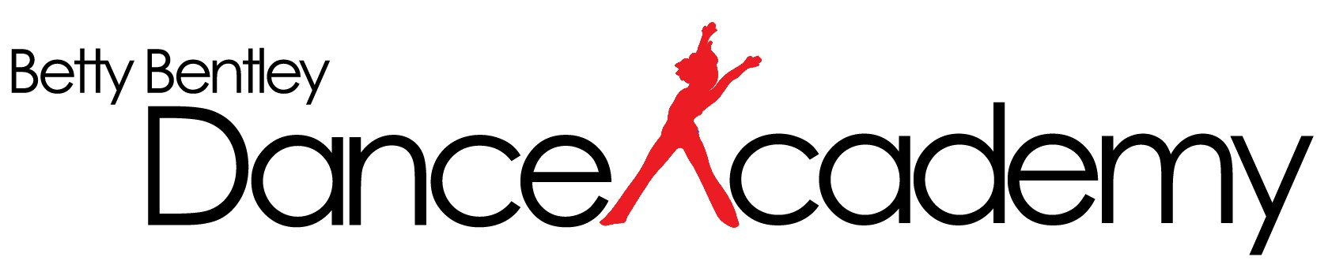
Willetton Studio

AGE | DAY | TIME | GRADE |  | AGE | DAY |  | TIME | GRADE
Combination Class Jazz / Classical |  |  |  |  | CLASSICAL BALLET
3– 4 Classical/Jazz | Saturday | 9.30 – 10.15 | Kinder |  | 5 – 7 Beginner | Friday |  | 4.00 – 4.45 | Primary
5 Classical/Jazz | Saturday | 10.15 - 11.00 | Pre-Primary |  | 9 -10 Beginner | Friday |  | 4.45 – 5.45 | Grade 1
 |  |  |  |  |  | Monday |  | 4.00 – 5.00 | Grade 2
JAZZ |  |  |  |  |  | Monday |  | 4.00 – 5.00 | Grade 3
6 – 8 | Saturday | 9.30 – 10.15 | Primary |  |  | Monday |  | 5.00 – 6.00 | Grade 5
9 – 10 | Saturday | 11.45 – 12.30 | Junior 2 |  |  | Friday |  | 5.45 – 6.30 | Grade 5 – 2nd class
11 - 12 | Tuesday | 4.45 – 5.45 | Junior 3 |  |  | Monday |  | 5.00 – 5.45 | Grade 7
 | Tuesday | 4.45 – 5.45 | Elementary 1 |  |  | Monday |  | 5.45 – 6.15 | Grade 7 Pointe
 | Tuesday | 6.30 – 7.30 | Elementary 3 |  |  | Wednesday |  | 4.00 – 5.00 | Grade 7 Class
 | Tuesday | 6.45 – 8.00 | Intermediate 3 |  |  | Monday |  | 5.45 – 6.15 | Intermediate Pointe
 | Thursday | 7.00 – 8.00 | Senior |  |  | Monday |  | 6.15 – 7.00 | Intermediate Class
 | Monday | 6.00 – 7.00 | Adult |  |  | Wednesday |  | 5.00 – 6.00 | Intermediate 2nd Class
 |  |  |  |  |  | Wednesday |  | 6.00 – 6.30 | Advanced Pointe
 |  |  |  |  |  | Wednesday |  | 6.30 – 7.30 | Advanced Ballet
TAP |  |  |  |  | HIP HOP
6 - 8 Beginners | Saturday | 10.15 – 11.00 | Primary |  | 6 - 9 Beginner | Wednesday |  | 4.30 – 5.15 | Hip Hop 1
9 - 12 Beginner | Saturday | 11.00 – 11.45 | Junior 2 |  | 10 -12 Beginner | Wednesday |  | 5.15 - 6.00 | Hip Hop 2
 | Tuesday | 4.00 – 4.45 | Junior 3 |  | 13+ Experienced | Wednesday |  | 6.00 – 6.45 | Hip Hop 3
 | Tuesday | 5.45 – 6.30 | Elementary 2
 | Tuesday | 5.45 – 6.45 | Intermediate 1
 | Wednesday | 7.30 – 8.15 | Senior Tap |  | ACROBATICS
 | Monday | 7.00 – 7.45 | Adult |  | 6+ Beginners | Thursday |  | 4.00 - 5.00 | Class 1 (Level 1 & 2)
 | Monday | 7.00 – 7.45 | Adult Adv. |  |  |  | Thursday | 5.00 – 6.15 | Class 2 (Level 3 & 4)
 |  |  |  |  |  | Thursday |  | 6.15 – 7.30 | Class 3 (Level 5 & 6)
CONTEMPORARY
Junior Jazz 8 - 11 | Saturday | 12.30 – 1.15 | Junior Contemporary
Elementary Jazz 12 - 14 | Thursday | 4.00 - 5.00 | Elementary Contemporary
Intermediate Jazz 15 -17 | Thursday | 5.00 - 6.00 | Intermediate Contemporary
Advanced Jazz - Exp | Thursday | 6.00 – 7.00 | Advanced Contemporary

